How To use the Website as an Admin

Contents

Logging into the Admin Site 2

Creating Certifications 2

Creating Time Limited Certifications 3

Creating Non Time Limited Certifications 3

Deleting Certifications from the Database 3

Creating New Roles 4

Deleting the Roles 4

Adding Roles to a User 4

Marking a user Active/Inactive 5

Giving Admin Permissions to other users 5

Using the Admin Dashboard 5

# Logging into the Admin Site

1. To login into the Admin Site at the base url add /admin. You also need to have admin permissions which can given by other admins or super admin.
   1. www.example.com/admin
   2. You should see something like this. Enter the same credentials used during registration Graphical user interface, application

      Description automatically generated

# Creating Certifications

1. You can create certifications by clicking certifications
   1. A screenshot of a computer

      Description automatically generated with medium confidence
2. Click Add Certifications on the top right
   1. A screenshot of a computer

      Description automatically generated with medium confidence
3. Follow one of the 2 following paths below and save or continue to add more certifications.
   1. Certifications can be published meaning if you want them to be shown on the employee side you can select publish to allow it. (this can also be changed later by selecting the certification and clicking the drop down)

## Creating Time Limited Certifications

1. If the certification has an expiration date Click Time Limited and add the expiration time for the certification in days
   1. Graphical user interface, application

      Description automatically generated

## Creating Non Time Limited Certifications

1. If the certification has no expiration date or is a one time certification, Time Limited should be a white box and
   1. Graphical user interface, application

      Description automatically generated

# Deleting Certifications from the Database

1. Select the certification
   1. Graphical user interface, application

      Description automatically generated
2. Use the drop down menu and select `Delete Selected Certifcations` then select the Go option
   1. Graphical user interface, text, application, chat or text message

      Description automatically generated

# Creating New Roles

1. Use the side bar and click Roles. This should be the view
   1. A screenshot of a computer

      Description automatically generated with medium confidence
2. Click Add Role in the Top left
3. Name the role and Use “Control + click” to multiselect all the certifications that apply to the roles
   1. Graphical user interface, application

      Description automatically generated

# Deleting the Roles

1. Similar to the deletion of certifications
   1. Select the role
   2. Select Delete Selected Roles
   3. Click Go

# Adding Roles to a User

1. Select the profiles tab on the side bar
   1. A screenshot of a computer

      Description automatically generated with medium confidence
2. Select the profile
   1. A screenshot of a computer

      Description automatically generated with medium confidence
3. Using “Hold down “Control”, or “Command” on a Mac, to select more than one” role to apply

## Marking a user Active/Inactive

1. Select the Active tag for Active. Deselect for Inactive
   1. 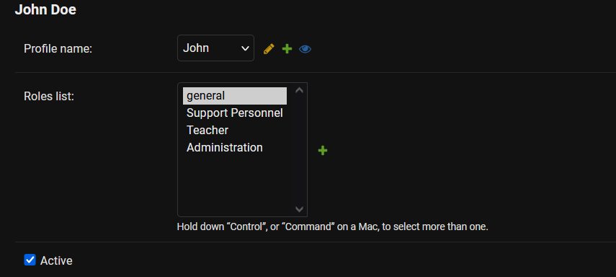

# Giving Admin Permissions to other users

1. Click Users on the side bar
   1. A screenshot of a computer

      Description automatically generated with medium confidence
2. Select a User
3. Scroll Down to the Permissions section and select Staff Status
   1. Graphical user interface, application

      Description automatically generated

# Using the Admin Dashboard

1. On the main dashboard login using your credentials. The rows are expandable so you can see the progress of ALL employees
   1. Text

      Description automatically generated